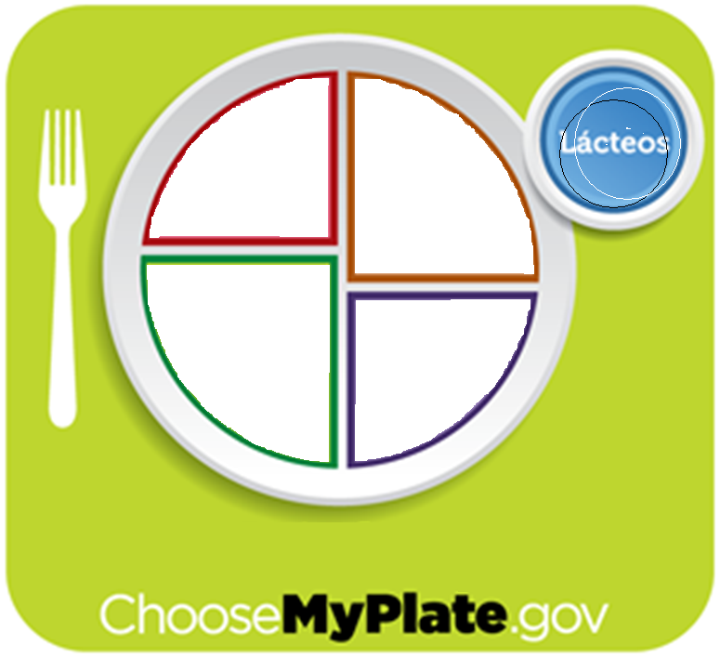

**Choose a healthier meal!**

* **Make half of your plate fruits & vegetables!**
* **Make at least half your grains whole grains!**
* **Switch to fat-free or low-fat (1%) milk**

**Paste pictures onto a paper plate of a healthier meal than what you just ate. Look at the following web site for assistance: http://www.choosemyplate.gov/**

PROTIEN

VEGETABLES

FRUIT

GRAIN

DAIRYY